

&



Installation Guide

***Version 21.1.0***

Table of Contents

Summary 3

Component Overview 4

Functional Overview 4

Use Cases 4

Limitations & Constraints 5

Compatibility 5

Privacy & Payment 5

Implementation Guide 6

Setup 6

Configuration 6

Dashboard Configuration 10

Dashboard Setup 10

Custom Code 13

Pipelines 15

Controllers (SGJC) 20

Pipelines & Controllers (SG storefront core) 28

SFRA 37

External Interfaces 38

Firewall Requirements 38

Testing 38

Operations & Maintenance 39

Data Storage 39

Availability 39

Support 39

User Guide 40

Roles & Responsibilities 40

Business Manager 40

Storefront Functionality 40

IOI Promotion 40

Known Issues 42

Release History 43

# Summary

The purpose of this document is to help system integration partners and developers implement the Ordergroove solution as it pertains to the Salesforce Commerce Cloud platform.

Ordergroove provides frictionless shopping experiences and a recurring, predictable and profitable revenue stream for Salesforce customers through subscriptions, reorder, memberships, clubs and boxes. The cartridge allows for omnichannel subscriptions, secure payment, and access to Ordergroove's best-in-class recurring revenue platform, the Relationship Commerce Cloud.

The cartridge is fully compatible with the Storefront Reference Architecture (SFRA) and also has support for Site Genesis (Pipelines & SGJC).

# Component Overview

## Functional Overview

The cartridge enables data flow between SFCC and Ordergroove through various API calls and feeds:

1. The product feed enables SFCC to send Ordergroove an updated list of products in the product catalog, along with prices and availability
2. Subscription creation is enabled through an HTTPS POST (referred to as Purchase Post), which informs Ordergroove when a checkout is completed; additional data is sent when there is a subscription product that is checked out by the customer
3. Customer information is kept in sync between the two systems
4. Order placement is enabled by creating a secure endpoint to which Ordergroove posts recurring orders for a customer on their behalf; this functionality hooks into core SFCC functionality, including, but not limited to, tax calculation, payment authorization, transactional emails, and order export for downstream fulfillment

A full list of features and supported use cases is provided below, along with an overall data flow diagram.

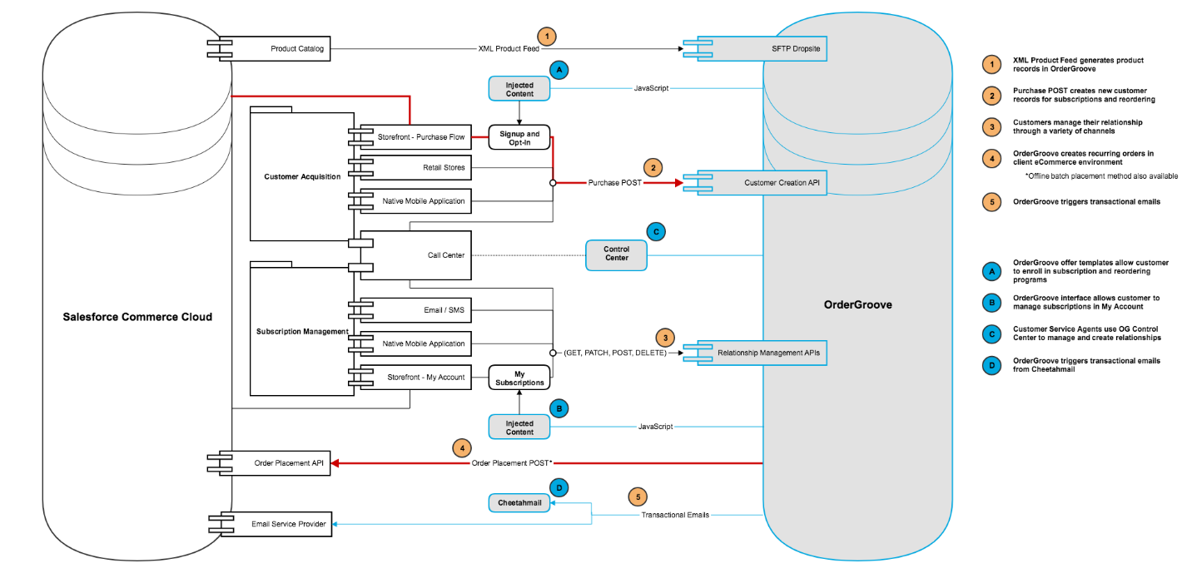

## Use Cases

Subscription Creation

* Creation attempt happens only after successful payment authorization.
* Site preferences for subscription configuration.
* Email notifications to IT system support for specific error codes.
* Automatic retry logic and purging for failed attempts.

Recurring Orders

* XML Requests and Responses.
* Final price is calculated after promotions and incentives for line items in order.
* Orders flow as a normal storefront web channel.
* Order-level incentives and shipping method site preference

Product Feed

* Site preferences for product feed configurations (price book ID & image view type).
* A scheduled job that can upload to the Ordergroove SFTP server as frequently as every 30 mins.

Customer Updates

* Synchronizes customer updates from the account profile (phone number or email address) with Ordergroove.

Payment Updates

* Synchronizes payment updates from the account profile (only when sending payment tokens) with Ordergroove.

Frontend Tagging

* Ordergroove “offers” (subscription enrollment widgets) use div and script tags that utilize JavaScript function calls.
* A base My Subscriptions Interface (MSI).

Signature Generation

* A hook extension which can be used to integrate with all Ordergroove APIs.

## Limitations & Constraints

Depending on client-specific needs, there may be additional customizations necessary to fine-tune the Ordergroove solution to meet expectations. The storefront may require tweaks to element selector classes or promotional considerations, which are not available in this cartridge.

This cartridge does not take multiple or split payments into consideration. In addition, the cartridge does not handle multiple or split shipments to different shipping addresses. The first payment and default shipment will be used with this cartridge.

## Compatibility

Certified and available since Commerce Cloud Store 21.6 (API Compatibility Mode 21.2) and SFRA 5.3.0. Also offers support of legacy pipeline implementations (not supported officially by SFCC).

## Privacy & Payment

Customer profile information being accessed is dependent on the selection of site preferences. Credit card account numbers can be AES encrypted and may be stored in Commerce Cloud for retry purposes only. All payment related information is AES encrypted in transit and at rest in Ordergroove’s database. All customer PII is AES encrypted at rest in Ordergroove’s database. In the case where Ordergroove must tokenize payment information, Ordergroove uses Paymetric as their tokenization vendor; Ordergroove is also PCI Level 1 Compliant.

# Implementation Guide

## Setup

The cartridge can be used with either Pipelines, Controllers, or Storefront Reference Architecture. One cartridge (int_ordergroove) is used for test and production environments containing all architectures. Only the merchant hash key, SFTP credentials, and service endpoint will differ based on environment. Generally, the cartridge is considered fully functional for Pipelines, SGJC, and SFRA. Be sure the following data is accessible:

|  |  |
| --- | --- |
| Metadata | File Name |
| Custom & System Object Type Definitions | ordergroove-sys-custom-obj-defs.xml |
| Services | services.xml |
| Job Schedules | jobs.xml |

The following table is a list of ISML templates in SFRA which will be overlaid with this cartridge:

|  |
| --- |
| **File Path Name** |
| account/dashboardProfileCards.isml |
| account/payment/paymentForm.isml |
| cart/productCard/cartProductCard.isml |
| common/scripts.isml |
| checkout/checkoutLogin.isml |
| checkout/confirmation/confirmation.isml |
| checkout/productCard/productCard.isml |
| product/productDetails.isml |
| product/quickView.isml |

## Configuration

Use a utility to create a zipped file for the **ordergroove-data-import** folderand navigate Business Manger into Administration >> Site Development >> Site Import & Export. Upload and import the zipped file, then skip to step 3. Otherwise, import the data manually by starting with step 1.

1. Import System & Custom Object Definitions
   1. Login to Business Manager
   2. Navigate: Administration >> Site Development >> Import & Export >> Upload
   3. Browse for **ordergroove-sys-custom-obj-defs.xml** and upload
   4. Click the back button and click the import metadata button
   5. Select **ordergroove-sys-custom-obj-defs.xml** and next button
   6. After the XML schema completes validation, choose import
2. Import Services & Job Schedules
   1. Navigate business manager: Administration >> Operations >> Import & Export >> Upload
   2. Browse for **services.xml** and upload
   3. Browse for **jobs.xml** and upload
   4. Click the back button and click the import button under the services section
   5. Select **services.xml** and next button
   6. After the XML schema completes validation, choose import
   7. Click the import button under the job schedules section
   8. Select **jobs.xml** and next button
   9. After the XML schema completes validation, choose import
3. Assign the cartridge to a site
   1. Navigate business manager: Administration >> Sites >> Manage Sites
   2. Select a site which will utilize the Ordergroove cartridge
   3. Choose the settings tab and add **int_ordergroove** to the beginning of the colon separated list if it is SFRA or to the end of the list if it is pipelines/controllers
   4. Repeat steps 3a through 3c for additional sites
   5. It is not necessary to add the int_ordergroove cartridge to the business manager site since the jobs are site-specific.
4. Update Site Preferences
   1. Navigate business manager with a site selected: Merchant Tools >> Site Preferences >> Custom Preferences >> Ordergroove
   2. Update every preference value as directed by the Ordergroove client solution partner
   3. Be sure to update the preferences based on instance type when promoting the integration to staging
5. Update URL Rules
   1. Navigate business manager with a site selected: Merchant Tools >> Site URLs >> URL Rules
   2. Select the pipeline URLs tab
   3. Create an alias **ordergroove** that resolves to **OrderGroove-OrderPlacement**
   4. Create an alias **auth** that resolves to **OrderGroove-Auth**
   5. Create an alias **authiframe** that resolves to **OrderGroove-AuthIframe**
   6. Create an alias **subscriptions** that resolves to **Account-MSI** (SFRA) or **OrderGroove-MSI** (SG)
   7. Provide the full URL based on step 5c to your Ordergroove client solution partner for all sites and environments where Ordergroove will be used (e.g. https://www.yoursite.com/ordergroove)
6. Update Services
   1. Navigate business manager: Administration >> Operations >> Services >> Service Credentials
   2. Choose **OrderGrooveCreateSubscription**
   3. Update the URL based on environment:

|  |  |
| --- | --- |
| Test | https://staging.sc. ordergroove.com/subscription/create |
| Production | https://sc. ordergroove.com/subscription/create |

d. User and password should be empty

1. Choose **OrderGrooveCustomerUpdate**
2. Update the URL based on environment:

|  |  |
| --- | --- |
| Test | https://staging.restapi. ordergroove.com/customers |
| Production | https://restapi. ordergroove.com/customers |

1. User and password should be empty
2. Choose **OrderGrooveUploadFeed**
3. Update the URL based on environment:

|  |  |
| --- | --- |
| Test | sftp://staging.feeds. ordergroove.com |
| Production | sftp://feeds. ordergroove.com |

1. **User and password should be populated** and provided by your Ordergroove client solution partner (this will be different for **test and production)**
2. Choose **OrdergroovePaymentUpdate**
3. Update the URL based on environment:

|  |  |
| --- | --- |
| **Test** | https://staging.v2.ordergroove.com/customer/update_payment_default |
| **Production** | https://api.ordergroove.com/customer/update_payment_default |

1. User and password should be empty
2. Update Job Schedules
   1. Navigate business manager: Administration >> Operations >> Job Schedules
   2. Choose **OrderGroovePurchasePostRetry**
   3. Select the schedule and history tab to ensure the job is **enabled** and **recurring every 10 minutes** for a non-sandbox environment.
   4. Select the resources tab and assign the job a system **resource lock** of **customobject**
   5. Select the step configurator tab and choose the applicable sites as **scope**
   6. Select the notification tab and enable/update the recipient notification **email address**
   7. Choose **OrderGrooveProductFeed**
   8. Select the schedule and history tab to ensure the job is **enabled** and **recurring every 30 minutes** for a non-sandbox environment.
   9. Select the resources tab and assign the job a system **resource lock** of **feed**
   10. Select the step configurator tab and choose the applicable sites as **scope**
   11. Select the notification tab and enable/update the recipient notification **email address**

## Dashboard Configuration

The Salesforce Ordergroove cartridge comes with a separate Business Manager plugin which allows you to login to and control the Ordergroove program directly from the Salesforce Business Manager interface. There are a couple of steps which are necessary to enable this functionality. Please take a look below for instructions.

## Dashboard Setup

1. Navigate to the Business Manager settings screen and append the **bm_ordergroove** cartridge to the cartridge path:

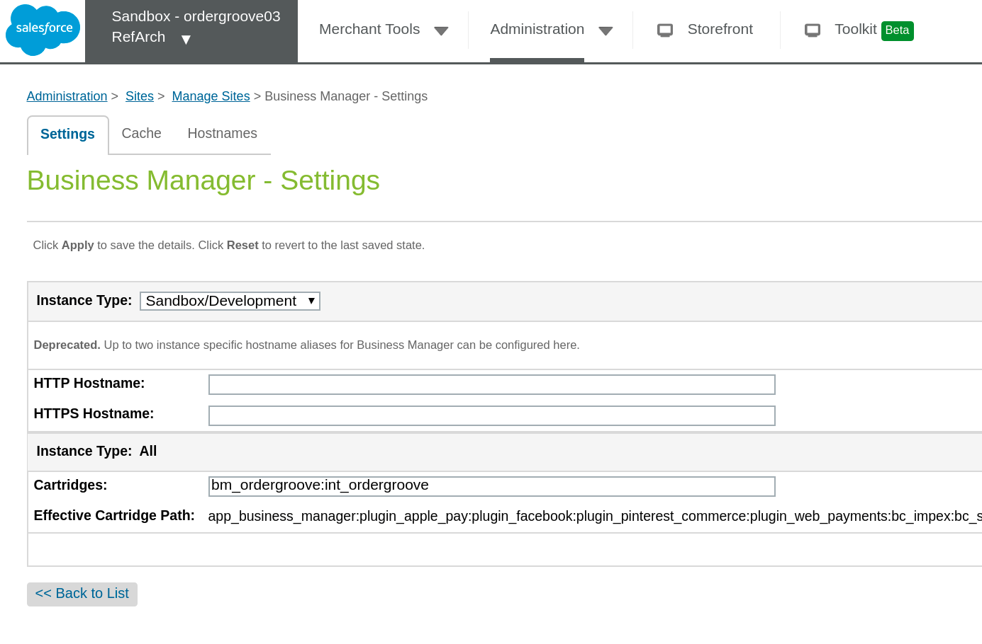

2. Once the **bm_ordergroove** cartridge has been added to Business Manager settings and your changes have been applied, you will need to configure permissions for the cartridge to enable Business Manager functionality. In order to do this, navigate to the Roles & Permissions area, choose a role and site for which you would like to enable this functionality.

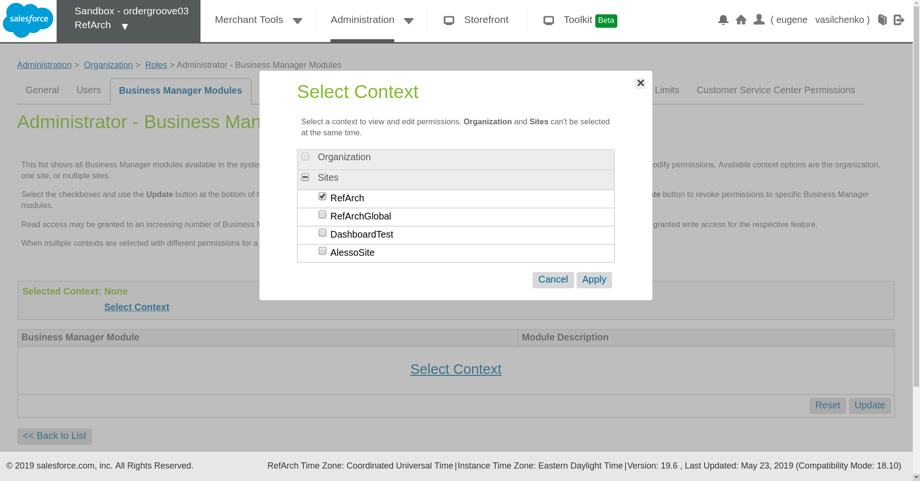

3. Once a site and role has been selected, just scroll down to the bottom of the page and enable the Ordergroove Dashboard:

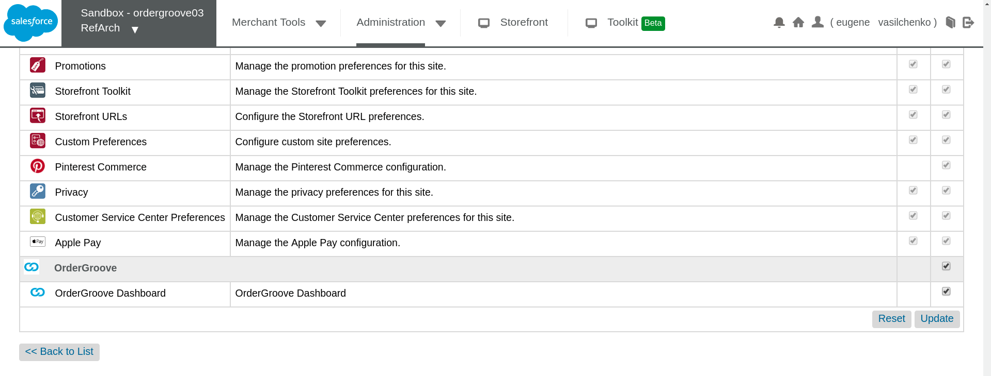

Enabling the cartridge will add the Ordergroove specific navigation links in the Merchant Tools dropdown and section:

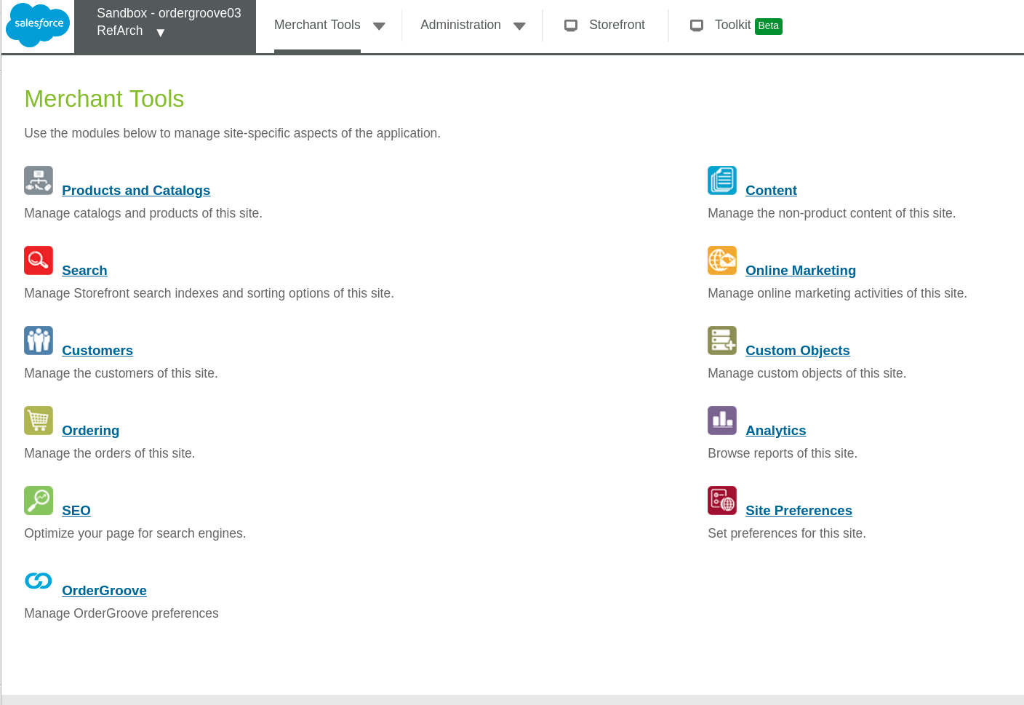

Once you navigate to Ordergroove dashboard, you can login using credentials provided to you by your Ordergroove contact and start managing your program:

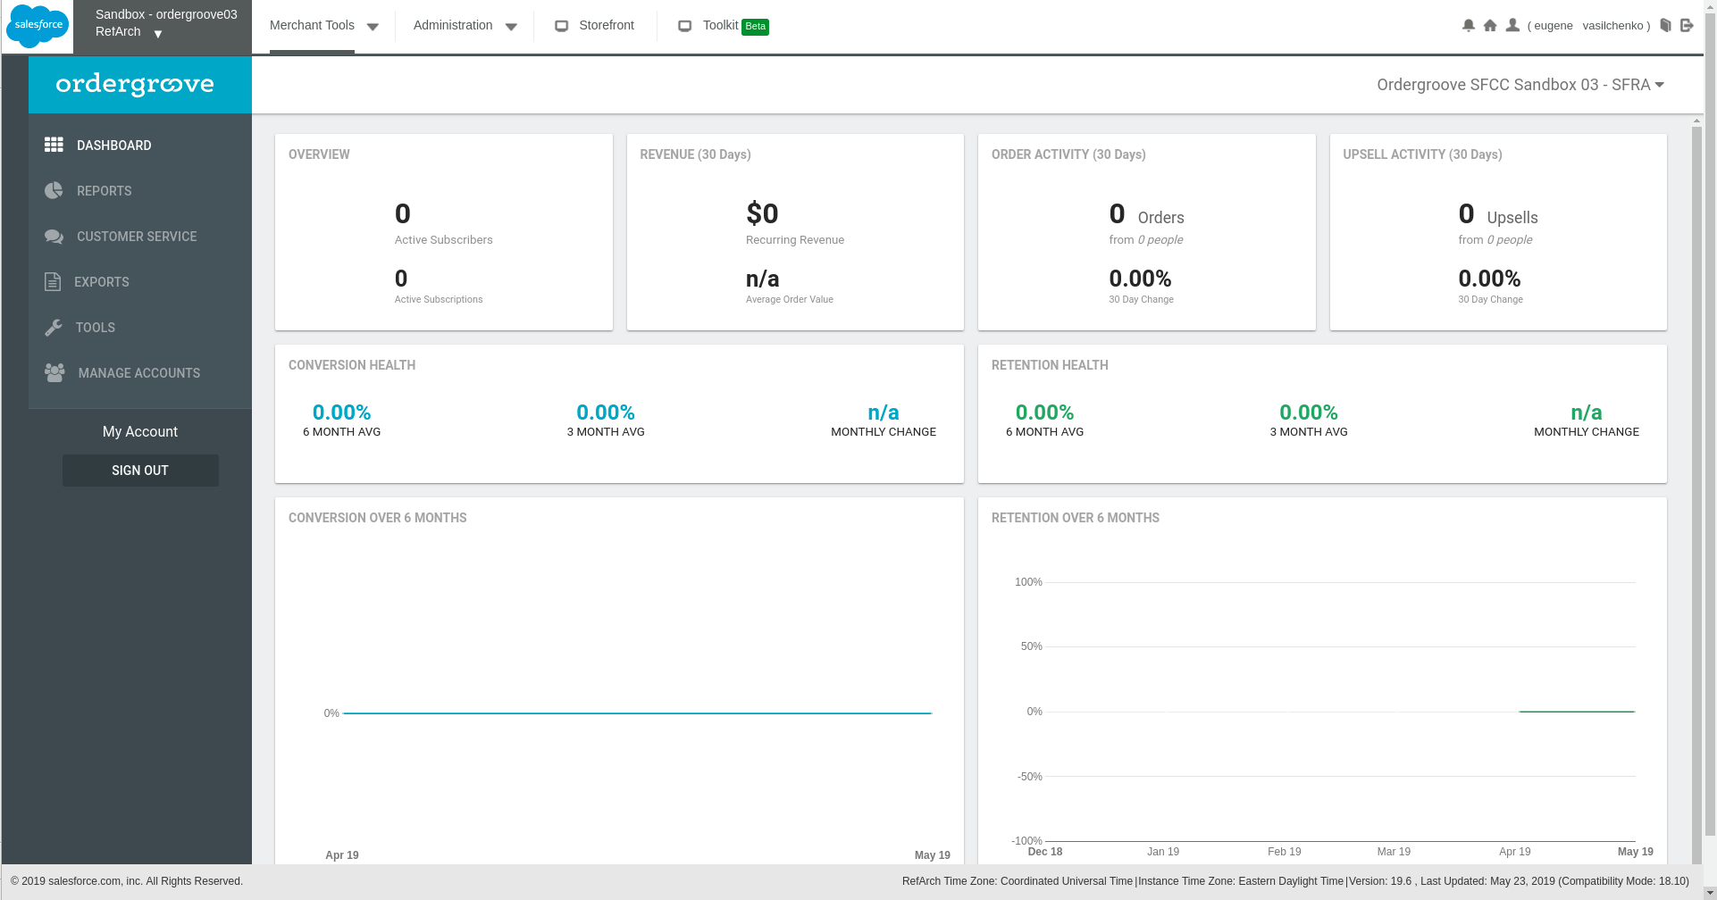

## Custom Code

Regardless of a site being SFRA, controller, or pipeline-based, there are two hooks and a preferred payment which need to be implemented for recurring orders in **OrderGroove.js**:

* Make the external tax call (if applicable)

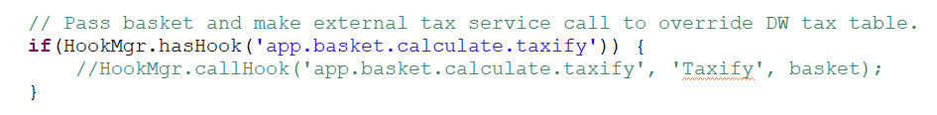

Replace the sample hook in **OrderGroove.js** with the vendor of your choice. If your site uses the platform’s built-in taxation table, then no changes are necessary. If your site is pipeline-based, it might be necessary to segment existing taxation logic by using the **hooks.json** file. Alternatively, you can call the pipeline from the controller using the **Pipeline Class** if your site API is compatible.

* Make the external payment service provider (PSP) call



The payment processor hook will be dynamic based on the selected payment processor for the given payment method within Business Manager. Out of the box, this is set to BASIC_CREDIT for Site Genesis and is converted to lower case basic_credit for SFRA. Ensure this hook is valid and functioning in **OrderGroove.js** with the payment gateway of your choice. If your site is pipeline-based, it might be necessary to segment existing payment authorization logic by using the **hooks.json** file. Alternatively, you can call the pipeline from the controller using the **Pipeline Class** if your site API is compatible.

Lastly, when using tokenization instead of sending the payment card number, it is assumed a **custom attribute named preferred** exists for the customer’s wallet.



Make a call to the Ordergroove Purchase POST endpoint during checkout for subscription creation and analytics. The code will ensure payment is authorized and the order was placed successfully prior to making the purchase post call.

For SFRA, the controller **CheckoutServices.js** will overlay and append the **PlaceOrder** function so no action is necessary.

For controllers, open **COPlacerOrder.js** and add the following highlighted code to the appropriate section:

|  |
| --- |
| require('int_ordergroove/cartridge/scripts/purchasePost').orderNo(order.getOrderNo()); |

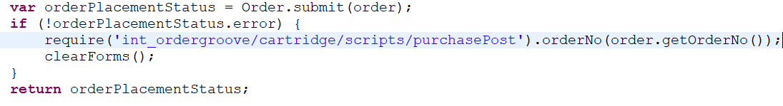

For pipelines, open **COPlaceOrder.xml** and add the highlighted call node:

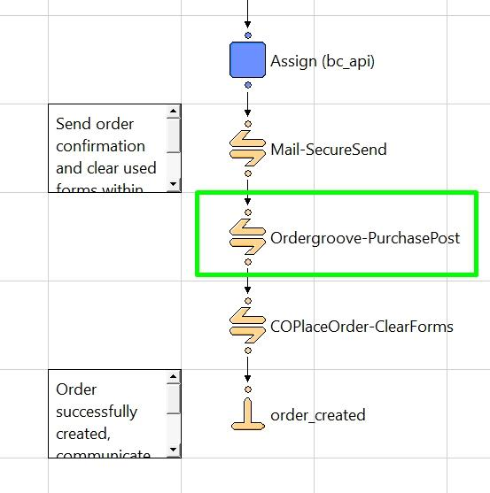



Integrate the customer update endpoint to keep Ordergroove synchronized with account profile changes.

For SFRA, the controller **Account.js** will overlay and append the **SaveProfile** function so no action is necessary.

For controllers, open **Account.js** and add the following highlighted code to the appropriate section:

|  |
| --- |
| require('int_ordergroove/cartridge/scripts/customerUpdate').sync(customer.getProfile()); |

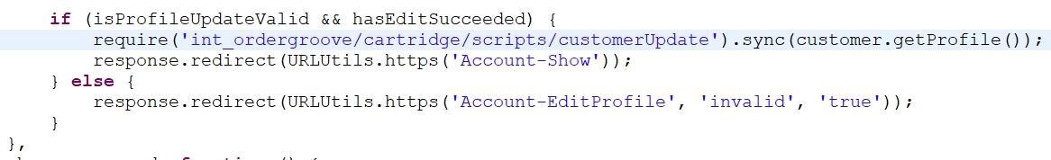

For pipelines, open **Account.xml** and add the highlighted call node:

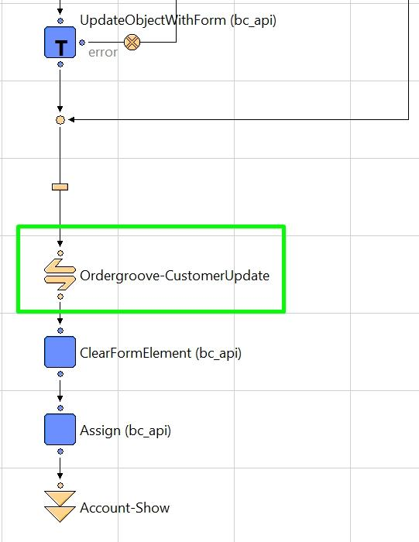



Add front-end page tagging and markup so that Ordergroove subscription offers will display throughout various areas on the site.

### Pipelines

Since one cartridge is used for all architectures and controllers take precedence over pipelines, delete the following controller files from the int_ordergroove cartridge (**only if using pipelines**):

|  |
| --- |
| **File Path Name** |
| int_ordergroove/cartridge/controllers/Account.js |
| int_ordergroove/cartridge/controllers/Cart.js |
| int_ordergroove/cartridge/controllers/Login.js |
| int_ordergroove/cartridge/controllers/Order.js |
| int_ordergroove/cartridge/controllers/Product.js |
| int_ordergroove/cartridge/controllers/PaymentInstruments.js |
| int_ordergroove/cartridge/controllers/Search.js |

Modify **Login.xml** and add the highlighted call node:

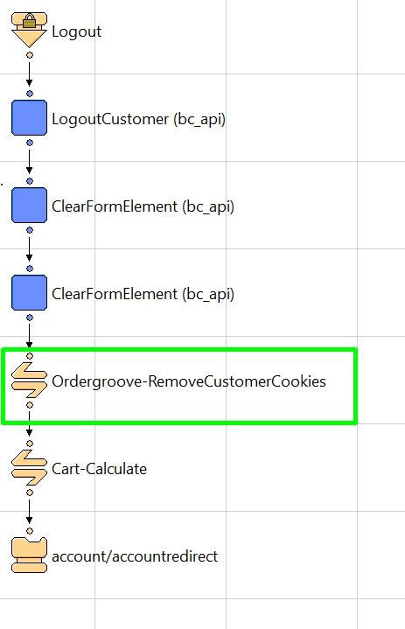

Modify **Search.xml** and add the highlighted call node:

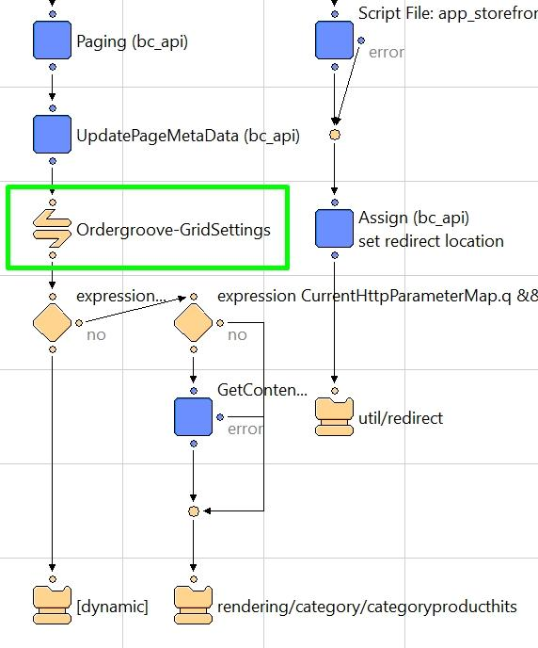

Modify **Product.xml** and add the highlighted call node:

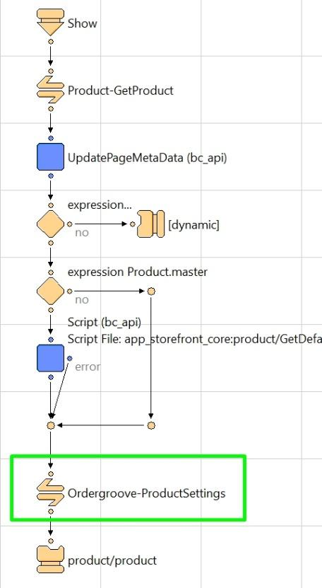

Modify **Cart.xml** and add the highlighted call node:

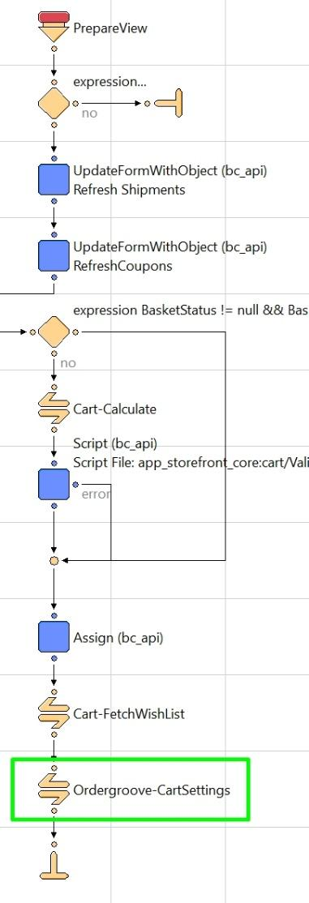

Modify **COCustomer.xml** and add the highlighted call node:

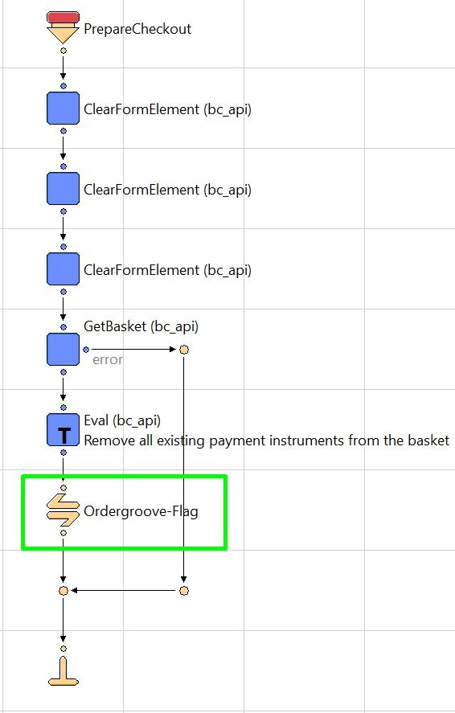

Modify **COShipping.xml** and add the highlighted call node:

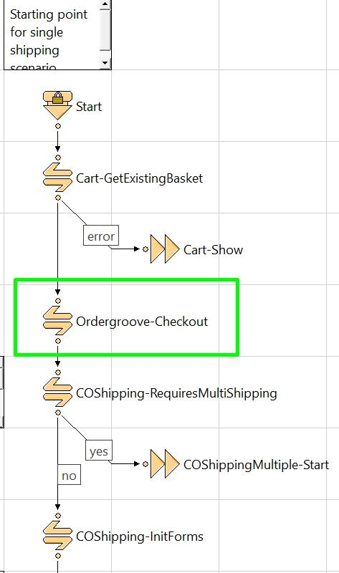

Modify **COBilling.xml** and add the highlighted call nodes:

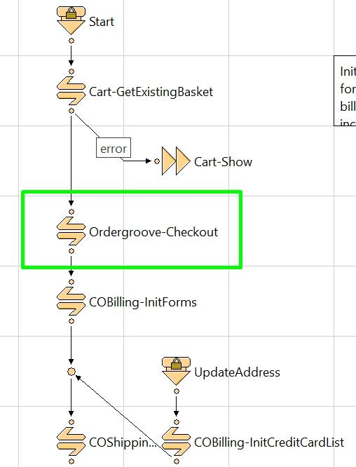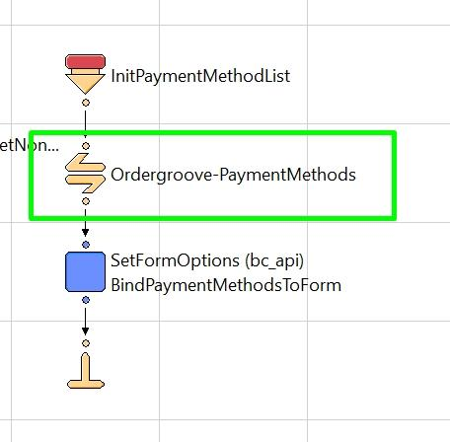

Modify **COSummary.xml** and add the highlighted call nodes:

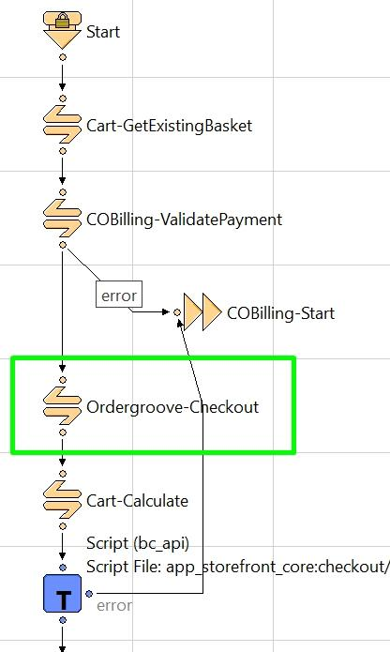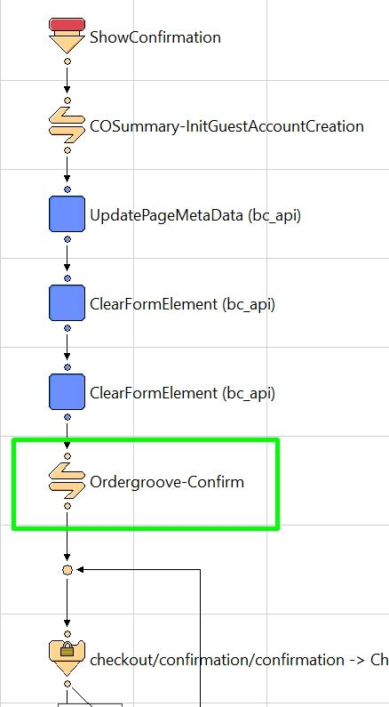

### Controllers (SGJC)

Modify **Login.js** and add the following line to the appropriate section:

|  |
| --- |
| require('int_ordergroove/cartridge/scripts/customerCookies').remove(); |

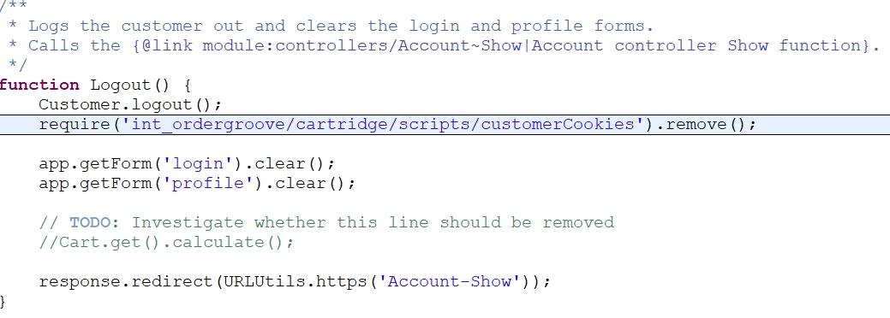

Modify **Search.js** and add the two lines to the appropriate sections:

|  |
| --- |
| var productSettings = require('int_ordergroove/cartridge/scripts/search').getSettings(); |
| productSettings: productSettings, |

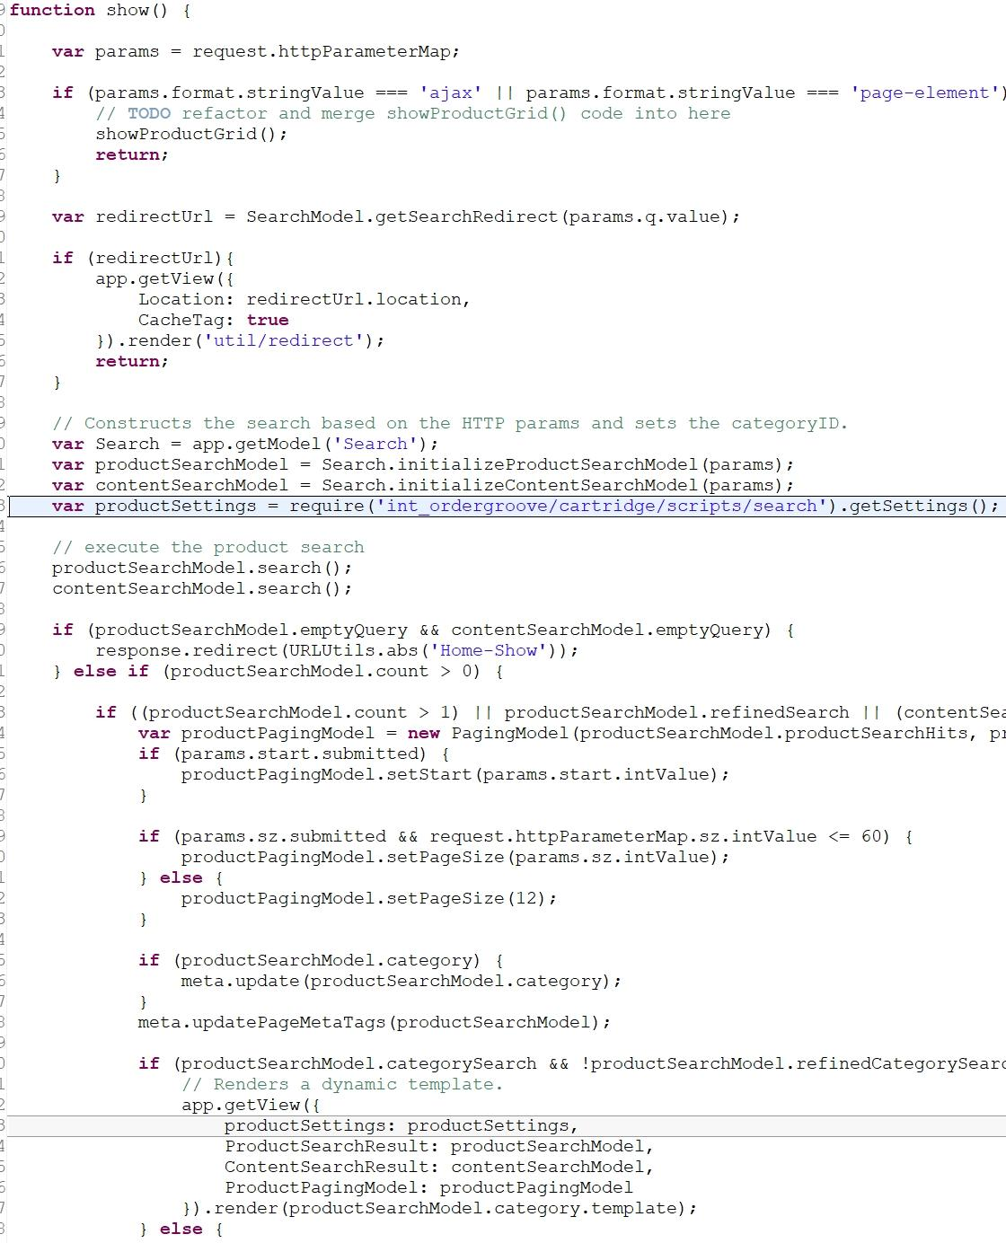

Modify **Product.js** and add the two lines to the appropriate sections:

|  |
| --- |
| var productSettings = require('int_ordergroove/cartridge/scripts/product').getSettings(product); |
| productSettings: productSettings, |

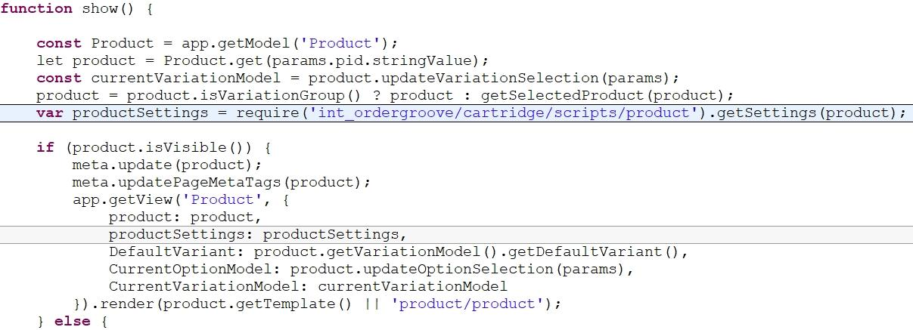

Modify **Cart.js** and add the two lines to the appropriate sections:

|  |
| --- |
| var productSettings = require('int_ordergroove/cartridge/scripts/cart).getSettings(); |
| productSettings: productSettings, |

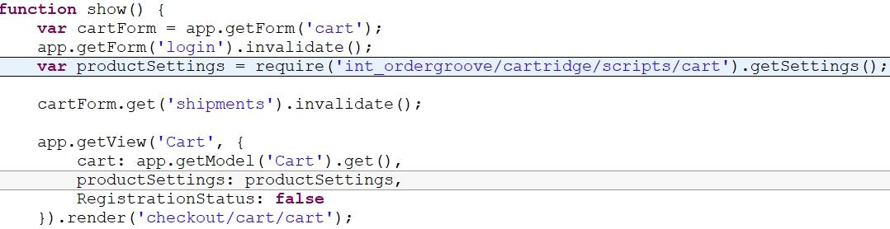

Modify **COCustomer.js** and add the two parts to the appropriate sections:

|  |
| --- |
| var autoShip = false;  if (dw.system.Site.getCurrent().getCustomPreferenceValue('OrderGrooveLegacyOffer') === null || dw.system.Site.getCurrent().getCustomPreferenceValue('OrderGrooveLegacyOffer') === true) {  autoShip = dw.system.HookMgr.callHook('ordergroove.customer', 'isAutoShip', request.getHttpHeaders().get('cookie'));  } else {  var BasketMgr = require('dw/order/BasketMgr');  var basket = BasketMgr.getCurrentOrNewBasket();  autoShip = dw.system.HookMgr.callHook('ordergroove.customer', 'isNewAutoShip', basket);  } |
| autoShip: autoShip, |

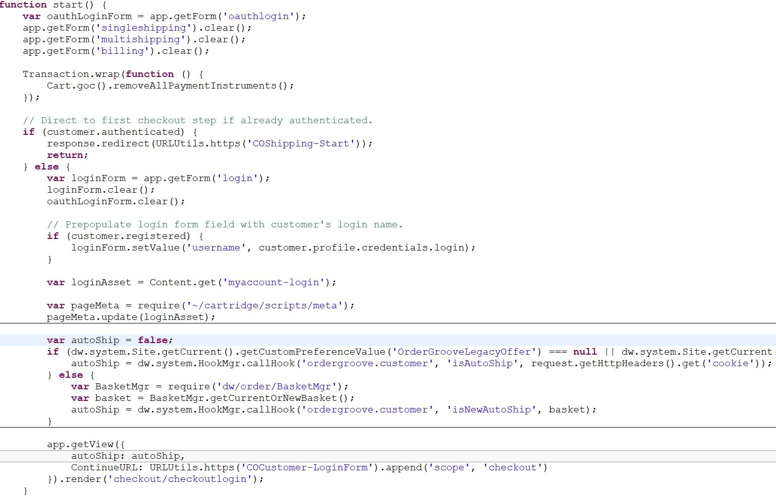

Modify **COShipping.js** and add three lines to the appropriate section:

|  |
| --- |
| require('int_ordergroove/cartridge/scripts/autoShipCustomer').validate(customer, response); |
| var productSettings = require('int_ordergroove/cartridge/scripts/checkout').getSettings(); |
| productSettings: productSettings, |

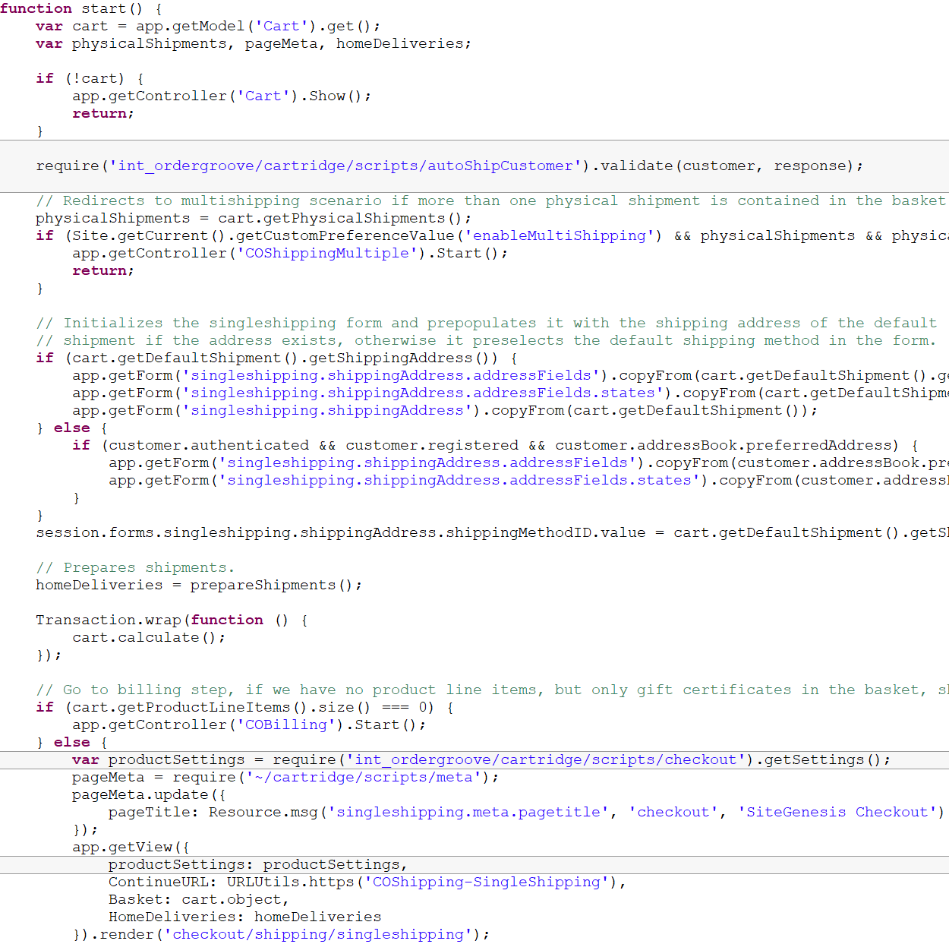

Modify **COBilling.js** and add the lines to the appropriate sections:

|  |
| --- |
| var productSettings = require('int_ordergroove/cartridge/scripts/checkout').getSettings(); |
| productSettings: productSettings, |

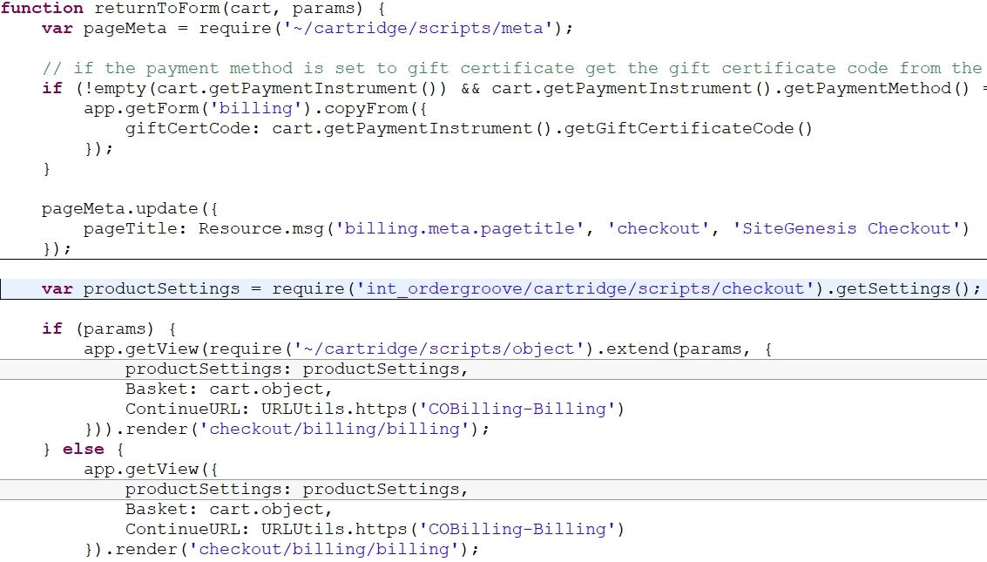

|  |
| --- |
| applicablePaymentMethods = require('int_ordergroove/cartridge/scripts/autoShipPaymentMethods').filter(applicablePaymentMethods, customer); |

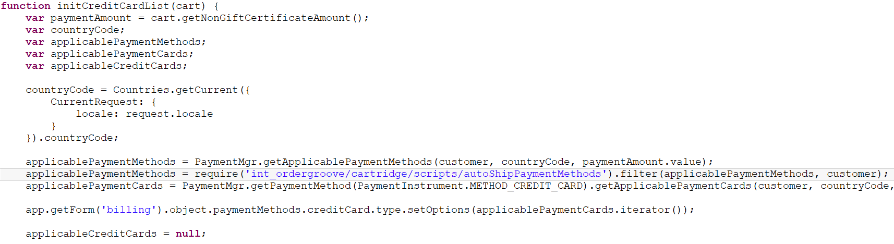

|  |
| --- |
| require('int_ordergroove/cartridge/scripts/autoShipCustomer').validate(customer, response); |

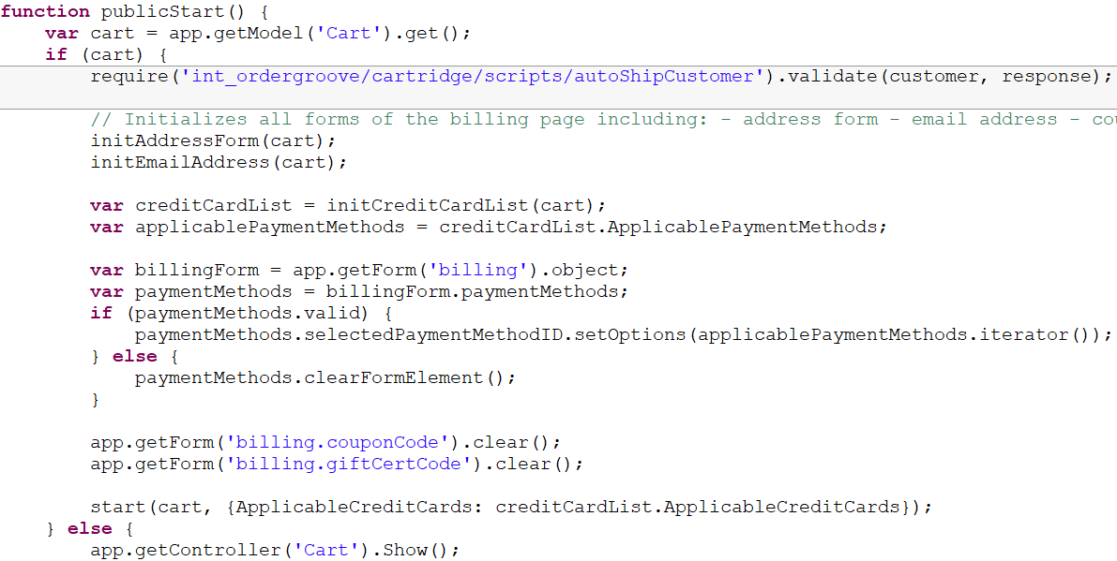

Modify **COSummary.js** and add the lines to the appropriate sections:

|  |
| --- |
| require('int_ordergroove/cartridge/scripts/autoShipCustomer').validate(customer, response);  var productSettings = require('int_ordergroove/cartridge/scripts/checkout').getSettings(); |
| productSettings: productSettings, |

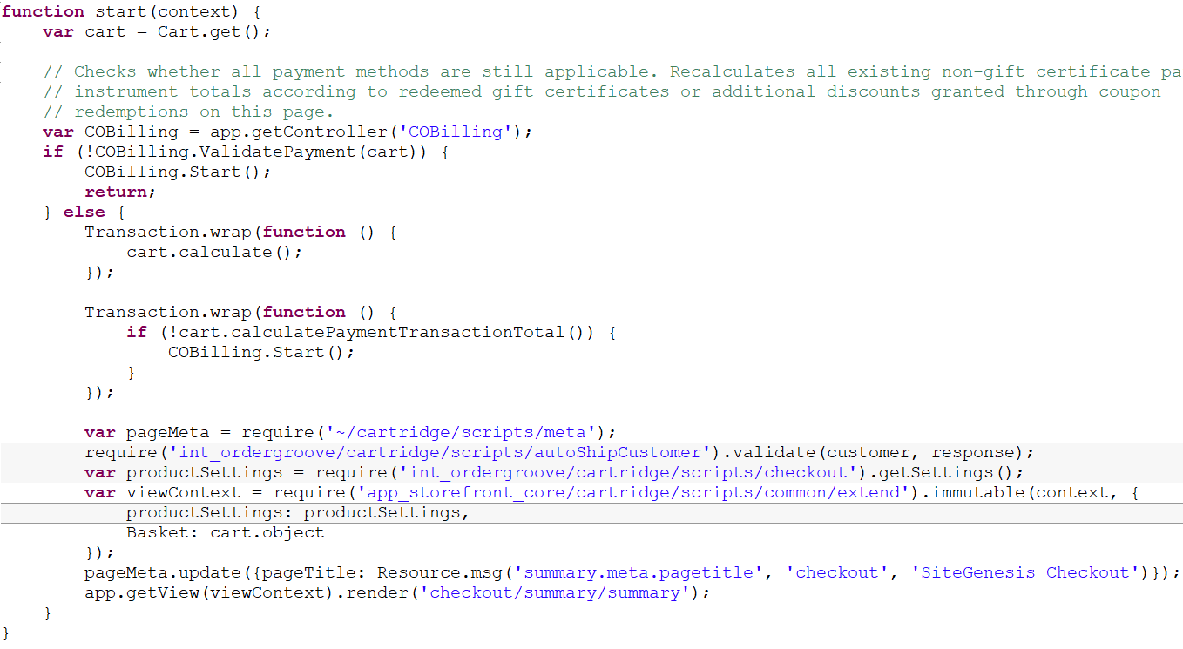

|  |
| --- |
| require('int_ordergroove/cartridge/scripts/cartAutoShipCookie').remove();  var productSettings = require('int_ordergroove/cartridge/scripts/confirmation').getSettings(); |
| isConfirmStage: true,  productSettings: productSettings, |

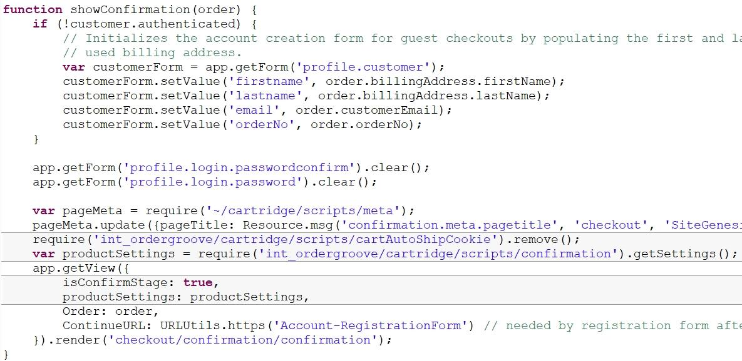

### Pipelines & Controllers (SG storefront core)

The function calls are an important part of displaying Ordergroove offers and so the JavaScript files need to compile into app.js to successfully display. Running gulp or grunt should build these files successfully.

Modify **index.js** and add the two lines to the appropriate sections:

|  |
| --- |
| var ordergroove = require('../../../../../int_ordergroove/cartridge/client/default/js/pages/product/pdp'); |
| ordergroove(); |

The required ordergroove module is relative to the site genesis storefront core. If your cartridge structure is different, then you may have to modify the path to compensate. The module being required is based on the site genesis HTML structure. If elements, classes, or IDs were modified, then additional customization will be necessary in **index.js**.

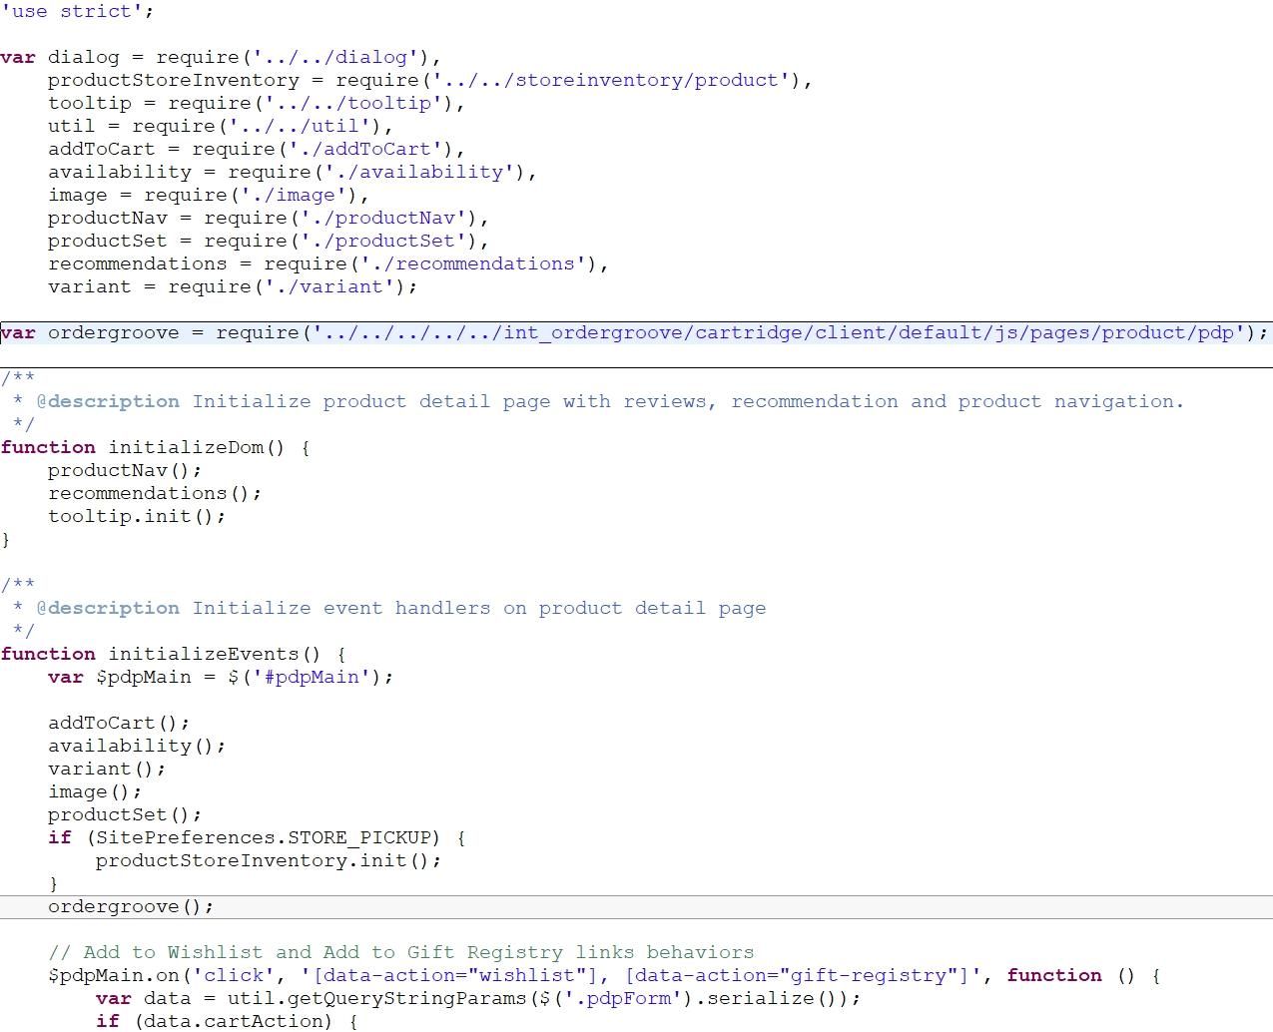

Modify **variant.js** and add the two lines to the appropriate sections:

|  |
| --- |
| var ordergroove = require('../../../../../int_ordergroove/cartridge/client/default/js/pages/product/pdp'); |
| ordergroove.updateProduct(); |

The required ordergroove module is relative to the site genesis storefront core. If your cartridge structure is different, then you may have to modify the path to compensate. The module being required is based on the site genesis HTML structure. If elements, classes, or IDs were modified, then additional customization will be necessary in **variant.js**.

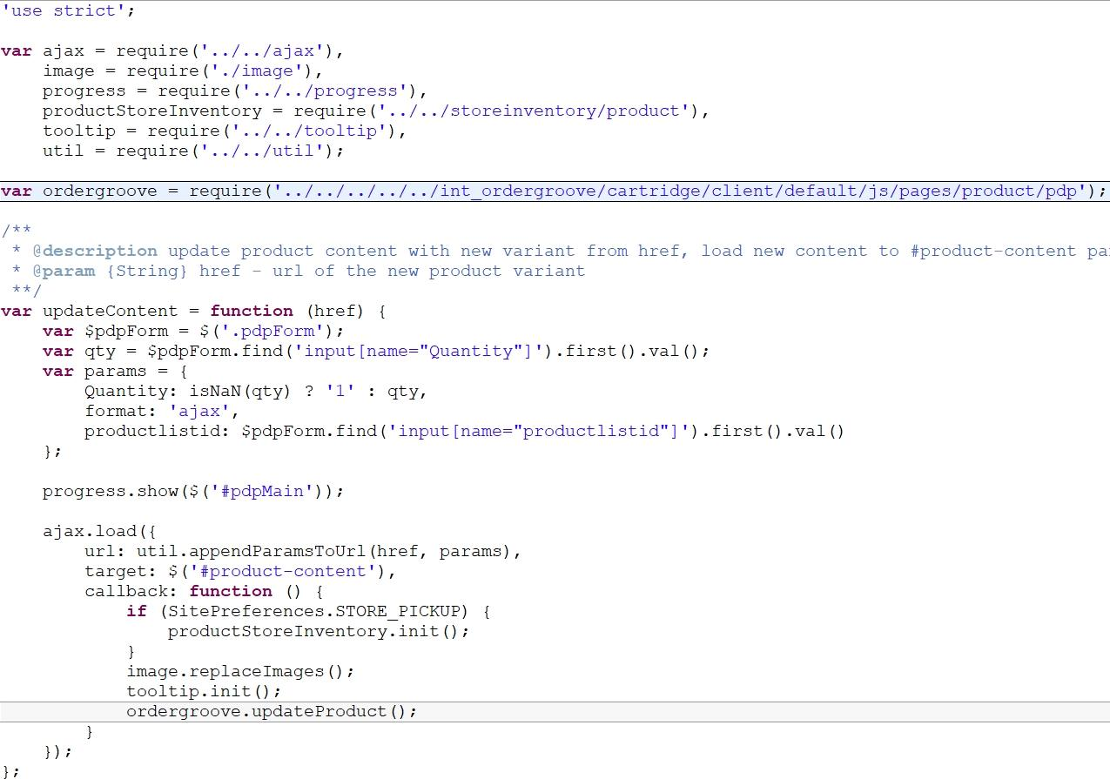

Modify **cart.js** and add the two lines to the appropriate sections:

|  |
| --- |
| var ordergroove = require('../../../../int_ordergroove/cartridge/client/default/js/pages/cart'); |
| ordergroove(); |

The required ordergroove module is relative to the site genesis storefront core. If your cartridge structure is different, then you may have to modify the path to compensate. The module being required is based on the site genesis HTML structure. If elements, classes, or IDs were modified, then additional customization will be necessary in **cart.js**.

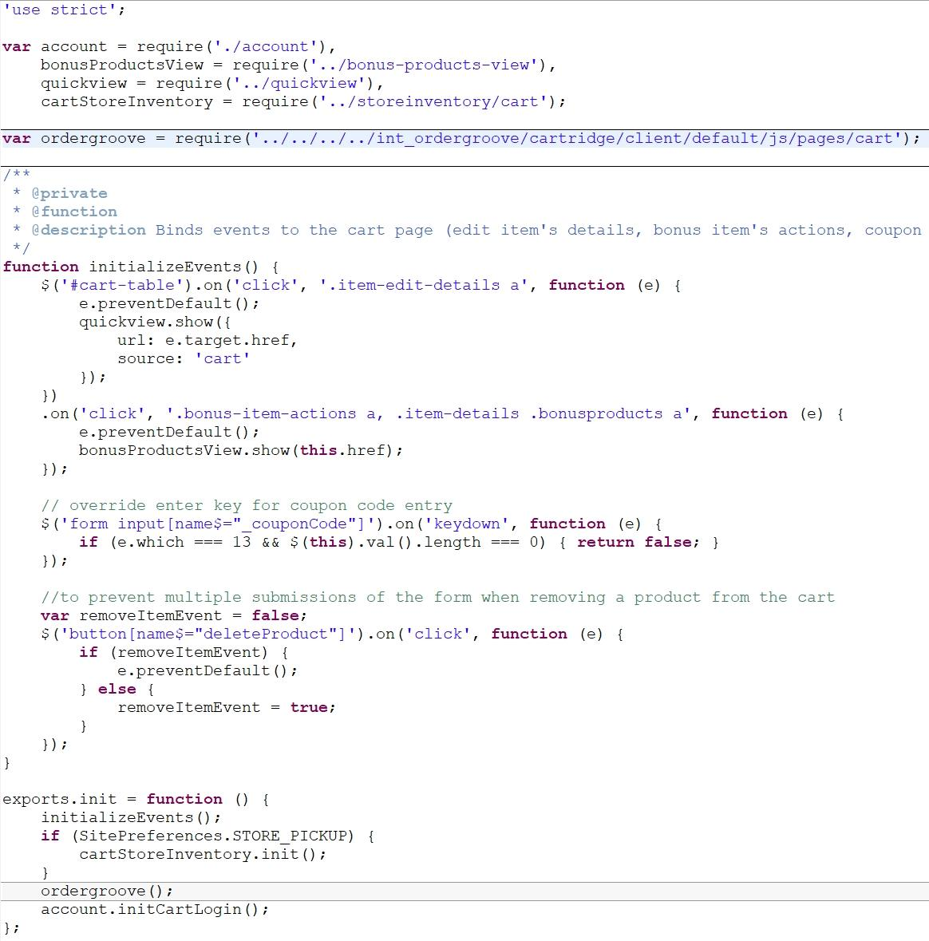

Modify **app.js** and add the line to the appropriate section:

|  |
| --- |
| require('../../../int_ordergroove/cartridge/client/default/js/optins')(); |

The required module is relative to the site genesis storefront core. If your cartridge structure is different, then you may have to modify the path to compensate.

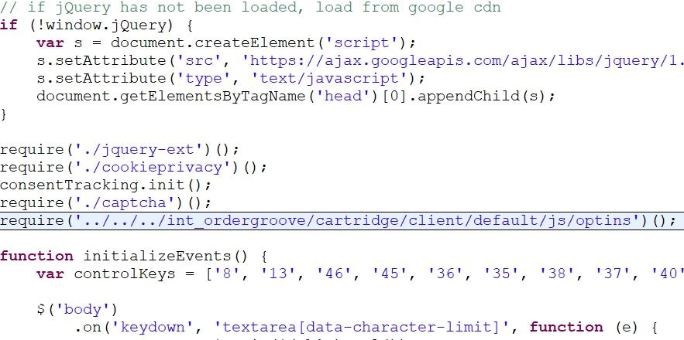

Modify **checkoutlogin.isml** and add the following condition containing guest checkout so that it will not display:

|  |
| --- |
| <isif condition="${pdict.autoShip !== true}">  ...  </isif> |

Modify **paymentinstrumentdetails.isml** and add the following include:

|  |
| --- |
| <isinclude template="payment/paymentinstrumentbilling"/> |

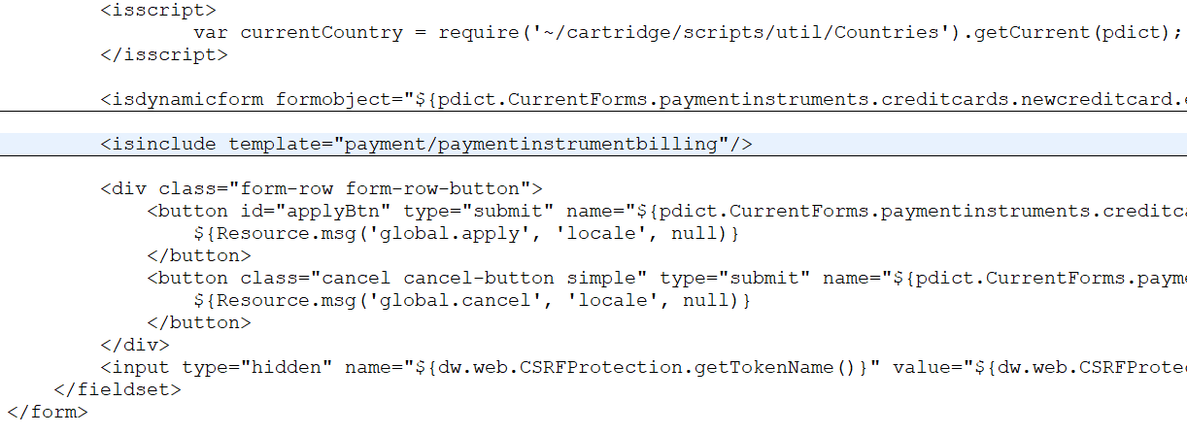

Modify **paymentinstruments.xml** and replace the form include name with the following:

|  |
| --- |
| <include formid="newcreditcard" name="billingcreditcard"/> |

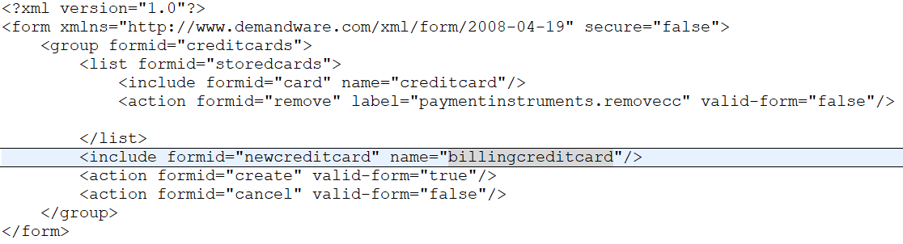

Modify **SaveCustomerCreditCard.ds** and add the following line:

|  |
| --- |
| require('*/cartridge/scripts/autoShipPaymentMethods').sync(customer, paymentInstr.getUUID(), creditCardFields); |

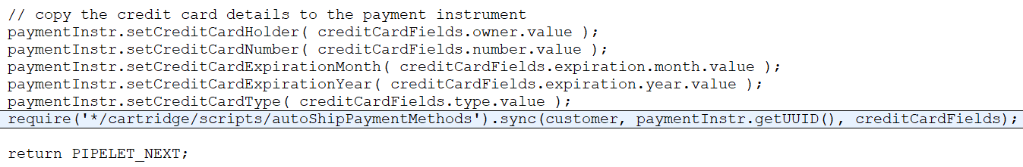

Modify **minilineitems.isml** and add the following markup where desired:

|  |
| --- |
| <iscomment>Ordergroove Offer</iscomment>  <isif condition="${!empty(dw.system.Site.getCurrent().getCustomPreferenceValue('OrderGrooveEnable')) && dw.system.Site.getCurrent().getCustomPreferenceValue('OrderGrooveEnable') == true}">  <isif condition="${empty(dw.system.Site.getCurrent().getCustomPreferenceValue('OrderGrooveLegacyOffer')) || dw.system.Site.getCurrent().getCustomPreferenceValue('OrderGrooveLegacyOffer') == true}">  <isif condition="${pdict.p_showreverse}">  <div class="og-offer" data-og-module="cart_flydown" data-og-product="${productLineItem.productID}"></div>  <iselse/>  <div class="og-offer" data-og-module="or" data-og-product="${productLineItem.productID}"></div>  </isif>  <iselse/>  <isif condition="${pdict.p_showreverse}">  <og-offer product="${productLineItem.productID}" location="cart"></og-offer>  <iselse/>  <og-offer product="${productLineItem.productID}"></og-offer>  </isif>  </isif>  </isif> |

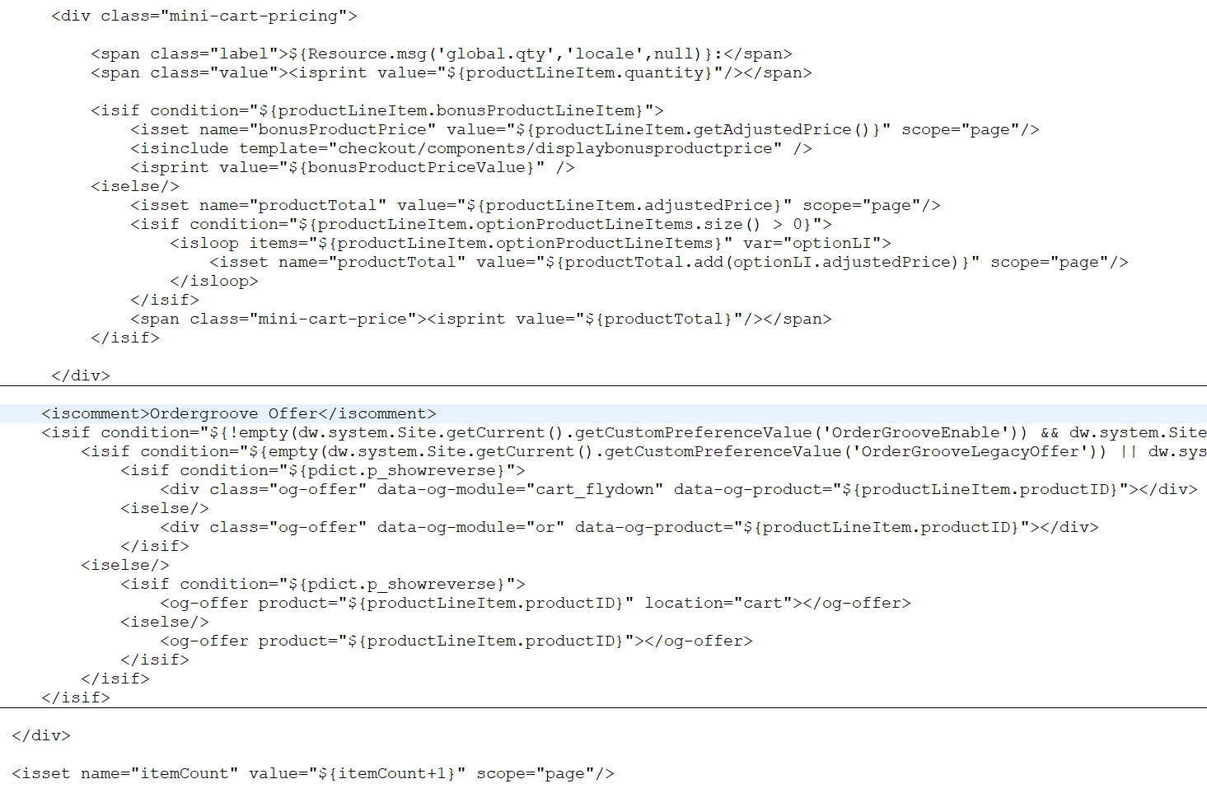

Modify **confirmation.isml** and add the following markup where desired:

|  |
| --- |
| <iscomment>Ordergroove Offer</iscomment>  <isinclude template="checkout/confirmation/confirmationCopy" /> |

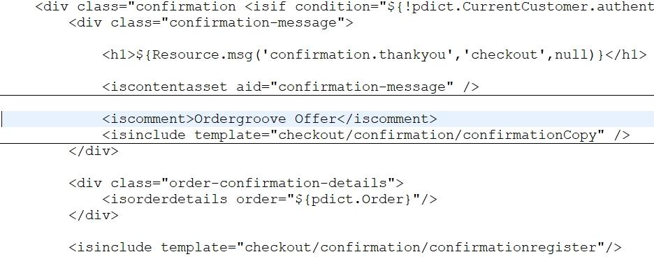

Modify **footer_UI.isml** and add the following markup before app.js:

|  |
| --- |
| <isinclude template="components/ordergroove"/> |

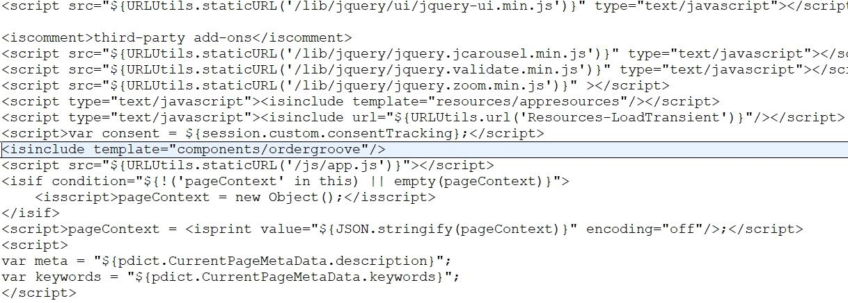

Modify **displayliproduct.isml** and add the following markup where desired:

|  |
| --- |
| <iscomment>Ordergroove Offer</iscomment>  <isif condition="${!empty(dw.system.Site.getCurrent().getCustomPreferenceValue('OrderGrooveEnable')) && dw.system.Site.getCurrent().getCustomPreferenceValue('OrderGrooveEnable')==true}">  <isif condition="${empty(dw.system.Site.getCurrent().getCustomPreferenceValue('OrderGrooveLegacyOffer')) || dw.system.Site.getCurrent().getCustomPreferenceValue('OrderGrooveLegacyOffer') == true}">  <isif condition="${!empty(pdict.isConfirmStage) && pdict.isConfirmStage == true}">  <div class="og-offer" data-og-module="conf" data-og-product="${productLineItem.getProductID()}"></div>  <iselse/>  <isif condition="${(pdict.p_editable === false) && (empty(pdict.order))}">  <div class="og-offer" data-og-module="or" data-og-product="${productLineItem.getProductID()}"></div>  <iselse/>  <div class="og-offer" data-og-module="sc" data-og-product="${productLineItem.getProductID()}"></div>  </isif>  </isif>  <iselse/>  <isif condition="${!empty(pdict.isConfirmStage) && pdict.isConfirmStage == true}">  <og-offer product="${productLineItem.getProductID()}"></og-offer>  <iselse/>  <isif condition="${(pdict.p_editable === false) && (empty(pdict.order))}">  <og-offer product="${productLineItem.getProductID()}"></og-offer>  <iselse/>  <og-offer product="${productLineItem.getProductID()}" location="cart"></og-offer>  </isif>  </isif>  </isif>  </isif> |

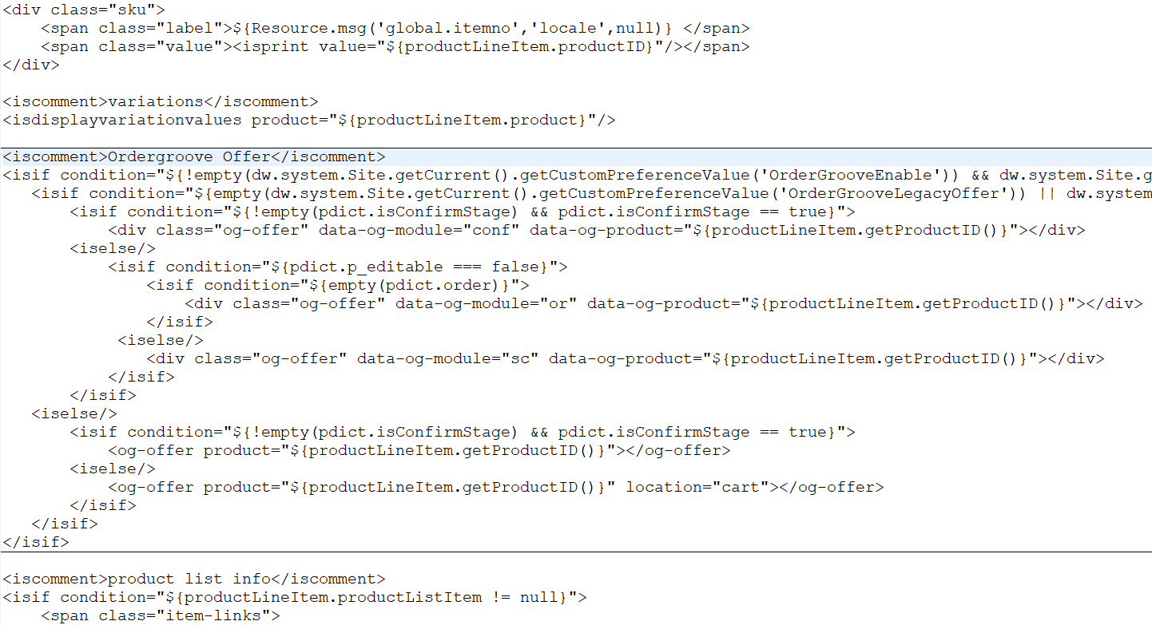

Modify **productcontent.isml** and add the following markup where desired:

|  |
| --- |
| <iscomment>Ordergroove Offer</iscomment>  <isif condition="${!empty(dw.system.Site.getCurrent().getCustomPreferenceValue('OrderGrooveEnable')) && dw.system.Site.getCurrent().getCustomPreferenceValue('OrderGrooveEnable') == true}">  <isif condition="${isQuickView}">  <isif condition="${pdict.CurrentHttpParameterMap.source.stringValue === 'quickview'}">  <isif condition="${empty(dw.system.Site.getCurrent().getCustomPreferenceValue('OrderGrooveLegacyOffer')) || dw.system.Site.getCurrent().getCustomPreferenceValue('OrderGrooveLegacyOffer') == true}">  <div class="og-offer" data-og-module="qv" data-og-product="*"></div>  <iselse/>  <og-offer product="${pdict.Product.getID()}"></og-offer>  </isif>  </isif>  <iselse/>  <isif condition="${empty(dw.system.Site.getCurrent().getCustomPreferenceValue('OrderGrooveLegacyOffer')) || dw.system.Site.getCurrent().getCustomPreferenceValue('OrderGrooveLegacyOffer') == true}">  <div class="og-offer" data-og-module="pdp" data-og-product="*"></div>  <iselse/>  <og-offer product="${pdict.Product.getID()}"></og-offer>  </isif>  </isif>  </isif> |

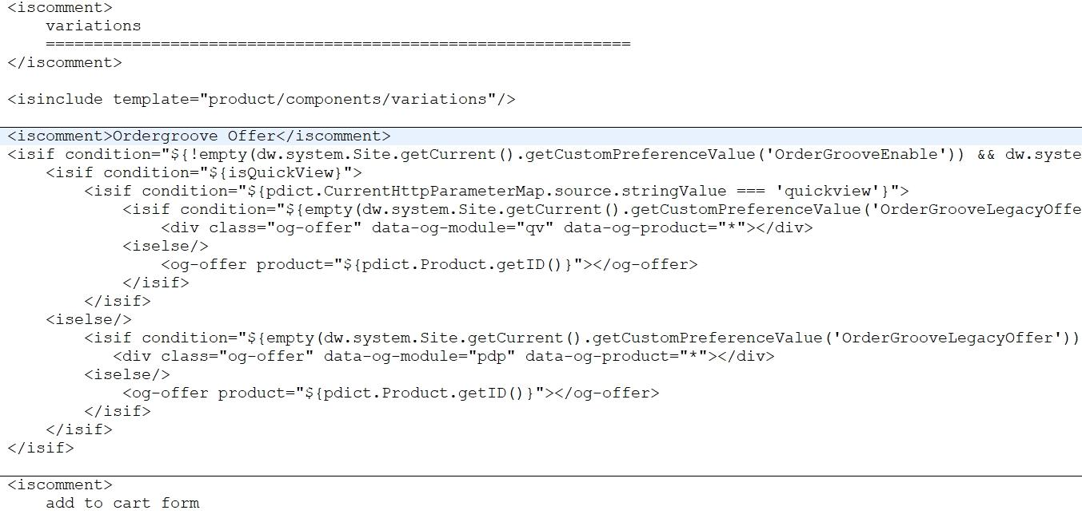

Modify content asset ID **account-nav-registered** and add a link for the subscription interface where desired:

|  |
| --- |
| <li><a title="Manage subscriptions" href="$httpsUrl(OrderGroove-MSI)$">My Subscriptions</a></li> |

### SFRA

The function calls are important for displaying Ordergroove offers so the JavaScript files need to compile into SFRA’s main.js to successfully display. Make sure **package.json** contains the correct directory for the SFRA project by reviewing the ‘**paths.base**’ property. Running npm should build these files successfully.

## External Interfaces

The outbound Ordergroove API requests use REST services to communicates via HTTPS POST. The inbound recurring order endpoint uses a guard that requires the request from Ordergroove to be delivered using HTTPS. The product feed communicates to Ordergroove servers via SFTP.

Ordergroove provides other APIs beyond the scope of this cartridge to enhance the user experience and meet the most sophisticated requirements. RPC endpoints may be provided in cases where the implementation of an action could be simplified by incorporating the business logic into a single endpoint. Please visit <https://developers.ordergroove.com/> for more information.

## Firewall Requirements

Most of the outbound services provided in the cartridge occur on port 80. However, the product feed places a file on the Ordergroove SFTP server using port 22 and may require a firewall change on the Commerce Cloud and Ordergroove side.

## Testing

Subscription offerings are merchant specific and will be available as soon as the product feed is received and ingested by Ordergroove. Once configurations have been made by OG, the cartridge can be tested after completing the integration guide.

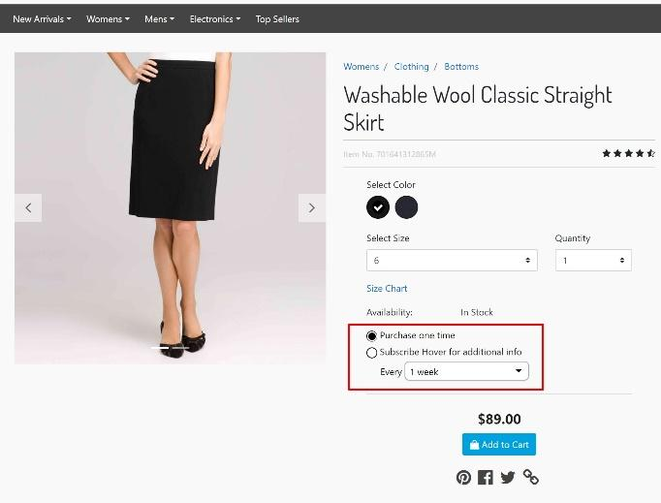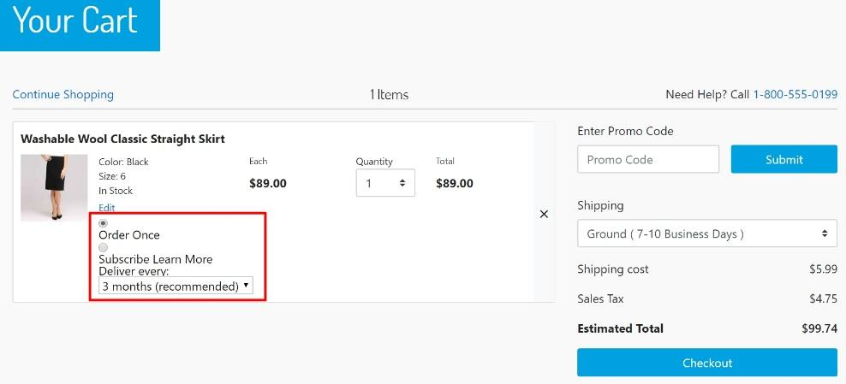

# Operations & Maintenance

## Data Storage

A custom object will be used to store data touch points in situations where failed attempts to create a subscription were made. These subscriptions will automatically be retried every 10 minutes within 24 hours. Each subscription retry will have retention set for 1 day from the time the order was placed. In the event the retry job is processed successfully, it will be purged before the 24-hour expiration. All custom objects will capture the order number as a key data point. However, only some implementations will store the Ordergroove session ID (based on a storefront cookie) or the AES encrypted credit card account number. The additional data will depend on client-specific site preferences being enabled.

Clients which do not have their own tokenizing payment vendor may elect to use Ordergroove’s tokenizing solution via AES encryption and the Paymetric secure data repository (SDR).

## Availability

Under highly stressed and overload conditions, Ordergroove servers may not respond immediately. Normally, these servers will recover within 10 minutes.

An email notification can be delivered to addresses in the site preference section for an initially failed subscription on certain response codes. Redundant email notifications will not be sent for retry attempts since it will be handled and reprocessed automatically. Please refer to the Ordergroove service level agreement (SLA) for more information.

If any production problems should occur, a master kill switch for the Ordergroove implementation is in place for all integration points. When disabled, the switch will also cause the job to cease from reprocessing failed subscriptions. It is important to note, any custom objects left in queue will be purged after a 24-hour expiration period. In addition, Ordergroove will not be able to place recurring orders via the Commerce Cloud endpoint when the Ordergroove integration has been disabled.

## Support

Please contact [customersupport@ordergroove.com](mailto:customersupport@ordergroove.com) for any defects or improvements.

# User Guide

## Roles & Responsibilities

The client will be responsible for any customizations with products (e.g. product options, bundles, variation groups, etc.) along with any SiteGenesis page tagging or additional feeds.

The client should go through an audit process with Ordergroove to ensure the validity of page tagging especially in cases where HTML elements, classes, and IDs have deviated from SiteGenesis.

Ordergroove will guide the client with a tailored experience by providing a client-specific integration guide. Ordergroove will also handle marketing related emails and styling for subscription offers or impulse upsells.

## Business Manager

Many configuration options are available in the Ordergroove site preference section and contain detailed descriptions for each preference.

## Storefront Functionality

New functionality will be evident on the product detail page (PDP), quick view on search results and product listing pages (PLP), and the cart page. The account section also contains a link to the ‘my subscription interface’ (MSI) on each user’s dashboard.

## IOI Promotion

The Initial-Order-Incentive Promotion, or IOI Promotion, allows the client to offer a discount to users for the first order in a new subscription. The IOI Promotion works exactly like other promotions in Salesforce, with a couple exceptions.

# Known Issues

When at least one subscription is selected in the cart, only a registered user may proceed through checkout and the payment method must be a credit card.

Split or multiple shipping address and split credit card payment are not available for use in this cartridge.

# Release History

|  |  |  |
| --- | --- | --- |
| Version | Date | Changes |
| 21.1.0 | June 28, 2021 | Added order-level incentives |
| 20.2.0 | May 11, 2020 | Added payment sync functionality |
| 20.1.0 | January 08, 2020 | Added new offers & SG tagging support |
| 19.1.0 | August 02, 2019 | Added new functionality |
| 18.1.0 | July 10, 2018 | Supporting SFRA |
| 17.1.0 | November 13, 2017 | New release |
| 15.1.0 | November 16, 2015 | Initial release |